**Topics: Descriptive Statistics and Probability**

1. Look at the data given below. Plot the data, find the outliers and find out $μ, σ, σ^{2}$

|  |  |
| --- | --- |
| **Name of company** | **Measure X** |
| Allied Signal | 24.23% |
| Bankers Trust | 25.53% |
| General Mills | 25.41% |
| ITT Industries | 24.14% |
| J.P.Morgan & Co. | 29.62% |
| Lehman Brothers | 28.25% |
| Marriott | 25.81% |
| MCI | 24.39% |
| Merrill Lynch | 40.26% |
| Microsoft | 32.95% |
| Morgan Stanley | 91.36% |
| Sun Microsystems | 25.99% |
| Travelers | 39.42% |
| US Airways | 26.71% |
| Warner-Lambert | 35.00% |

Answer:

import pandas as pd

import seaborn as sns

import matplotlib.pyplot as plt

data=pd.Series([24.23,25.53,25.41,24.14,29.62,28.25,25.81,24.39,40.26,32.95,91.36,25.99,39.42,26.71,35.00])

names = ["Allied Signal","Bankers Trust","General Mills","ITT Industries","J.P.Morgan & Co.","Lehman Brothers","Lehman Brothers","Marriott","MCI","Mereill Lynch","Microsoft","Morgan Stanley","Sun Microsystems","Travelers","US Airways","Warner-Lambert"]

%matplotlib inline

fig = plt.figure(figsize=(8,8))

sns.boxplot(data);

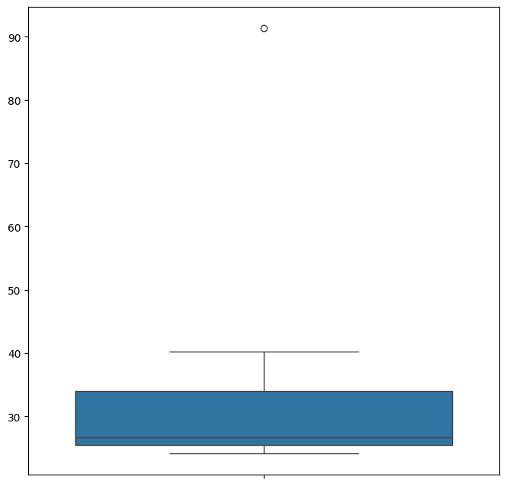

Outliers = 91.36%

round(data.mean(),4)

33.2713

round(data.std(),4)

16.9454

round(data.var(),4)

287.1466



Answer the following three questions based on the box-plot above.

1. What is inter-quartile range of this dataset? (please approximate the numbers) In one line, explain what this value implies.

Answer:

Here clearly 25 is the outlier.

Median = 7

1st quartile = 5

2nd quartile = 12

IQR = 12 – 5 = 7

* IQR tells us the range of the middle half of the data.

1. What can we say about the skewness of this dataset?

Answer:

Right-Skewed median is towards the left side, it is not normal distribution.

1. If it was found that the data point with the value 25 is actually 2.5, how would the new box-plot be affected?

Answer:

In that case there would be no outliers on the given dataset because of the outlier the data had positive skewness it will reduce and the data will normal distribution.



Answer the following three questions based on the histogram above.

1. Where would the mode of this dataset lie?

Answer:

Between 5 – 8 (Most frequent data).

1. Comment on the skewness of the dataset.

Answer:

It is positively skewed.

1. Suppose that the above histogram and the box-plot in question 2 are plotted for the same dataset. Explain how these graphs complement each other in providing information about any dataset.

Answer:

By comparing both of them, it is very clear that the data would be positively skewed. Also, would help us finding mean, mode value.

1. AT&T was running commercials in 1990 aimed at luring back customers who had switched to one of the other long-distance phone service providers. One such commercial shows a businessman trying to reach Phoenix and mistakenly getting Fiji, where a half-naked native on a beach responds incomprehensibly in Polynesian. When asked about this advertisement, AT&T admitted that the portrayed incident did not actually take place but added that this was an enactment of something that “could happen.” Suppose that one in 200 long-distance telephone calls is misdirected. What is the probability that at least one in five attempted telephone calls reaches the wrong number? (Assume independence of attempts.)

Answer:

Probability of call getting misdirected = (1/200)

Hence probability of call not getting misdirected = 1 – (1/200) = 199/200

Number of phone calls attempted = 5

Therefore, probability that at least one in 5 attempted call reaches the wrong number is:

= 1 – (199/200) ^ 5

=0.02475

1. Returns on a certain business venture, to the nearest $1,000, are known to follow the following probability distribution

|  |  |
| --- | --- |
| x | P(x) |
| -2,000 | 0.1 |
| -1,000 | 0.1 |
| 0 | 0.2 |
| 1000 | 0.2 |
| 2000 | 0.3 |
| 3000 | 0.1 |

1. What is the most likely monetary outcome of the business venture?

Answer:

The most likely monetary outcome of the business venture:

x = 2,000 with the highest probability of 0.3

1. Is the venture likely to be successful? Explain

Answer:

The venture is likely to be successful, because ( x = 1,000) + ( x = 2,000) + x ( x = 3,000) =0.2 + 0.3 + 0.1 = 0.6

1. What is the long-term average earning of business ventures of this kind? Explain

Answer:

|  |  |  |
| --- | --- | --- |
| x | P(x) | Income(x*P(x) |
| -2,000 | 0.1 | -200 |
| -1,000 | 0.1 | -100 |
| 0 | 0.2 | 0 |
| 1000 | 0.2 | 200 |
| 2000 | 0.3 | 600 |
| 3000 | 0.1 | 300 |
|  |  |  |
|  | Total | 800 |

1. What is the good measure of the risk involved in a venture of this kind? Compute this measure

Answer:

* Calculate the variance:

Var(X) = [(−2000 - 800)²(0.1) + (−1000 - 800)²(0.1) + (0 - 800)²(0.2) + (1000 - 800)²(0.2) + (2000 - 800)²(0.3) + (3000 - 800)²(0.1)]

= [(-2800²(0.1)) +(- 1800²(0.1)) + (-800²(0.2)) +( 200²(0.2)) + (1200²(0.3)) + (2200²(0.1))]

= [7840000(0.1) + 3240000(0.1) + 640000(0.2) + 40000(0.2) + 1440000(0.3) + 4840000(0.1)]

= [784000 + 324000 + 128000 + 8000 + 432000 + 484000]

= 2160000

* Calculate the standard deviation:

SD(X) = √Var(X)

= √2160000

≈ 1469.6938